1. **VL with Quadratic: data length, regression error, non-selt match threshold, k, alpha, anomalies, time**

(0-5000),14.5,0.1,1, 2.5,(4262-4398),00:00:13

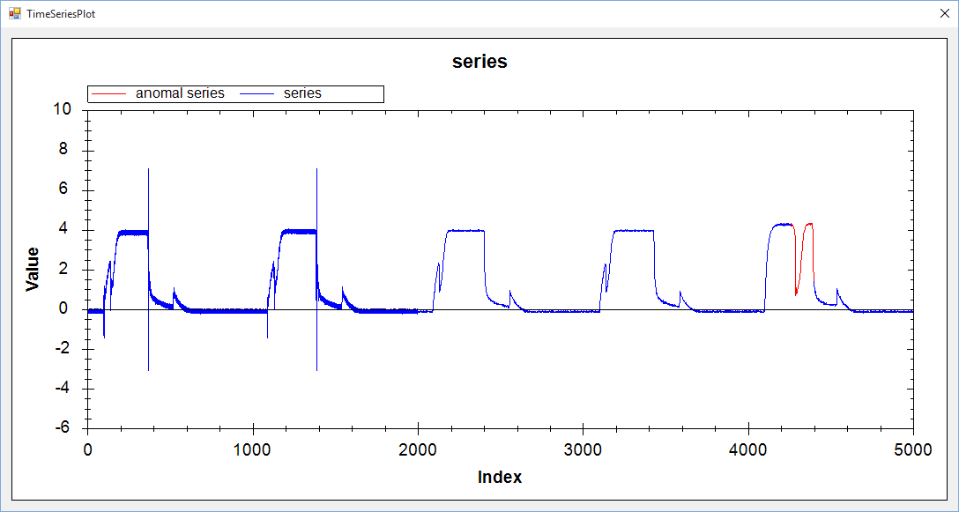

1. **VL with Extrem point: data length, ration, min length, k, alpha, anomalies, time**

(0-5000),1.02,50,1,3,(4197-4470),00:00:32

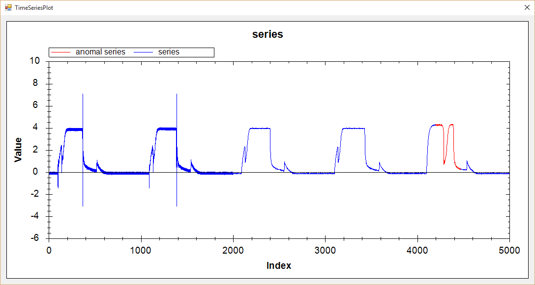

1. **Hot Sax: data length, anomaly length, paa length, discord begin, time**

(0-5000), 128, 8,4231,00:00:52

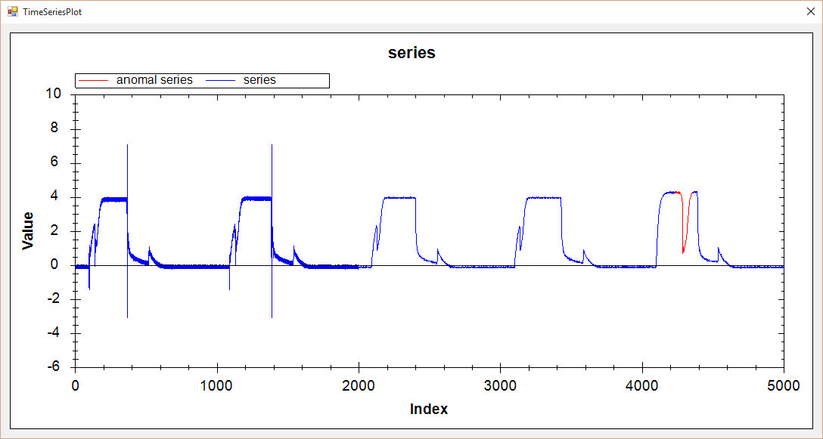

(0-5000), 200, 20,4282,00:00:49

